
June 1, 2024

Dear Homeowner!
As we approach a new Fiscal Year, we are sending you information required under the Declaration and By-Laws of Lake Country Village Homeowner’s Association, Inc. (Articles V and IX of the Declaration and Articles VI and VII of the By Laws, both available on our website.)
Included in this transmittal are:
1. Highlights of actions of the Board during the past fiscal year.
2. Copy of the final approved Budget for 2024-25. This document also contains a record of income and expenses from fiscal year 2023-24 (year to date) as compared to that year’s budget.
3. Payment Coupons for Fiscal Year 2024-25
4. Newsletter
The Certificate of Insurance will be posted on our website when it becomes available .
Beginning on July 1, 2024, the new monthly assessment will be $245.00. For those who use our autopay service, an extra $10 will automatically be added to the amount withdrawn. For all others, please begin paying the new amount starting with the July payment. If you use your bank’s Bill Pay service, please remember to update the amount being paid. Remember that if you are relying on a credit balance with us to cover future dues, the remaining credits may now not cover the new amount owed which could result in late fees or interest being applied. At our Annual Meeting of Members held May 13, 2024, the following homeowners were elected to the Board of Directors: Ron Deragon (re-elected), Judy Barcomb, Gerald Eagan, Jody Erickson. We welcome them to the Board and express our sincere gratitude to outgoing Directors, Kathy Firme and Randy LaMora.
We invite and encourage you to attend our regular meetings of the Board of Directors, to stay informed of issues facing the HOA and to participate by sharing your opinions and concerns. Meetings are posted on the Calendar on our website and are usually the second and fourth Monday of each month. Please consider getting involved in your HOA by joining one of the many committees formed to assist the Board. Information about our committees, can be found on our website, Committees/Duties - Lake Country Village (lcvillage.org).
It is also very important that you provide your up-to-date contact information (including tenant information) by filling out the “Contact Us” online form at Contact Us - Lake Country Village (lcvillage.org), whenever it changes.
Our website, - Lake Country Village (lcvillage.org) is the official location of all HOA documents and we encourage you to visit it regularly to see the latest news about your community. Our normal method of communication is via email which allows timely and efficient communication of important news. If you use email, make sure we have your email address by filling out the “Contact Us” form. Please “whitelist” the domains “lcvillage.org” and “ezvoteonline.com” to help ensure messages from us are not directed to your spam folder. Thank you for your kind attention to this letter.
Although the first point of contact for any questions you may have should normally be the Property Manager, please feel free to contact any of us directly as well.

Sincerely,
Your Board of Directors

The Year in Review
The following are some of the highlights of board action and accomplishments during the past fiscal year. For details
and a complete listing, see the minutes of Board Meetings.

May 2023
Elections Held via On-Line Voting. Winners for the 3 open seats were Dale Holzer, Margret Felty, Tammy Favro.
Started the process of closing the loan for our fences.

June 2023
Election of officers for 2023-2024 President Randy Lamora, Vice President Dave Andrews, Secretary Ron Deragon,
Treasurer Tammy Favro.
The onboarding of Buildium has started.

July 2023
Still having issues with roof leaks 4 roofs have been repaired.
Last payment to AFSCO this month for the fence project.

August 2023
180 homeowners have signed up for Buildium so far.
Lawn and snow contract will be going out for bid.

September 2023
We are going to see if we can get a grant for electrical upgrades.
More roof issues now we are finding that vent boots are being the source of the leaks.

October 2023
Board moving ahead with an attorney to address issues with the city of Plattsburgh.
Board wants to see if we can come up with a new board attorney since ours has been very busy.

November 2023
Complete Property Management came to the board meeting to meet homeowners and board members and answer
any questions they had.
Speed continues to be a problem in the Village and police were asked again if they could make the occasional patrol.

December 2023
Communication committee has a new Welcome Packet and will be handing them out soon.
People that went to the Christmas truck seemed to enjoy it and we will have them back next year.

January 2024
Dave Andrews, our VP, has moved so he has given up his seat and Kathy Firme will be filling in for the rest of Daves term.
We will be interviewing PM candidates in February.

February 2024
Board has voted to move the election of chair officers to July 1st so new board can vote on the officers.
With so many new heating systems being replaced the board wants to make sure homeowners know they are
responsible for any damage that might come from the installation .

March 2024
We interviewed 4 candidates for PM and was narrowed down to three and the board picked Mike McKinnon as our
new PM.
We are going to be sending out the yearly mailing package via email this year and the 7 people who don’t have email
we will mail them via USPS.

April 2024
We have 4 candidates for the open board seats and voting starts April 17th and ends May 13th.
Spring cleanup starts April 15th, weather permitting, and they will pick up brown bags every Monday weather permitting.
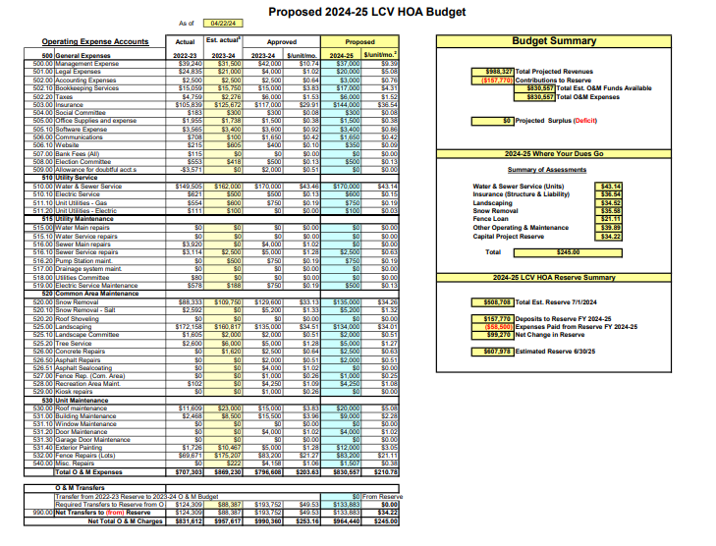

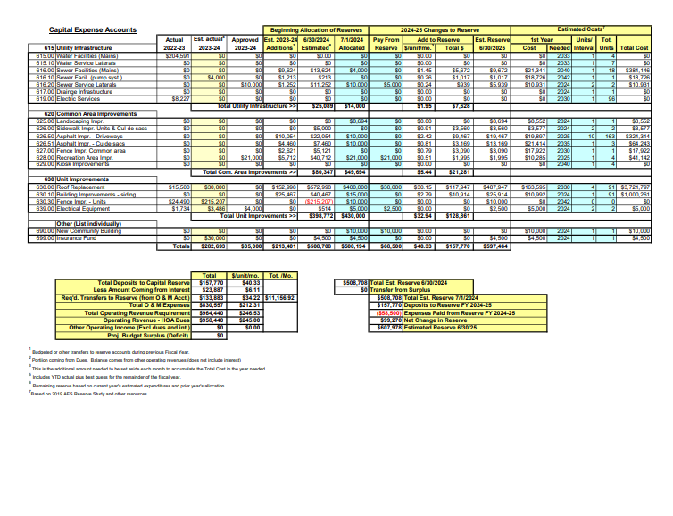

LAKE COUNTRY VILLAGE HOA – PLEASE USE THESE PAYMENT COUPONS IF PAYING BY PERSONAL CHECK
Lake Country Village Homeowners Association, Inc.  Monthly Dues of $245.00 Due July 1, 2024  Name _____________________________________  LCV Addr _______________________ Amt. Pd. $_______  Make check payable to LCV-HOA and mail with coupon to: Lake Country Village, 10 Maine Rd., Plattsburgh, NY 12903.  A $25 late fee will be applied to your account if payment is not received by the 10th of the month due. Interest at 9%/yr. will be added to all amounts outstanding after 30 days. | Lake Country Village Homeowners Association, Inc.  Monthly Dues of $245.00 Due August 1, 2024  Name _____________________________________  LCV Addr _______________________ Amt. Pd. $_______  Make check payable to LCV-HOA and mail with coupon to: Lake Country Village, 10 Maine Rd., Plattsburgh, NY 12903.  A $25 late fee will be applied to your account if payment is not received by the 10th of the month due. Interest at 9%/yr. will be added to all amounts outstanding after 30 days.
Lake Country Village Homeowners Association, Inc.  Monthly Dues of $245.00 Due September 1, 2024  Name _____________________________________  LCV Addr _______________________ Amt. Pd. $_______  Make check payable to LCV-HOA and mail with coupon to: Lake Country Village, 10 Maine Rd., Plattsburgh, NY 12903.  A $25 late fee will be applied to your account if payment is not received by the 10th of the month due. Interest at 9%/yr. will be added to all amounts outstanding after 30 days. | Lake Country Village Homeowners Association, Inc.  Monthly Dues of $245.00 Due October 1, 2024  Name _____________________________________  LCV Addr _______________________ Amt. Pd. $_______  Make check payable to LCV-HOA and mail with coupon to: Lake Country Village, 10 Maine Rd., Plattsburgh, NY 12903.  A $25 late fee will be applied to your account if payment is not received by the 10th of the month due. Interest at 9%/yr. will be added to all amounts outstanding after 30 days.
Lake Country Village Homeowners Association, Inc.  Monthly Dues of $245.00 Due November 1, 2024  Name _____________________________________  LCV Addr _______________________ Amt. Pd. $_______  Make check payable to LCV-HOA and mail with coupon to: Lake Country Village, 10 Maine Rd., Plattsburgh, NY 12903.  A $25 late fee will be applied to your account if payment is not received by the 10th of the month due. Interest at 9%/yr. will be added to all amounts outstanding after 30 days. | Lake Country Village Homeowners Association, Inc.  Monthly Dues of $245.00 Due December 1, 2024  Name _____________________________________  LCV Addr _______________________ Amt. Pd. $_______  Make check payable to LCV-HOA and mail with coupon to: Lake Country Village, 10 Maine Rd., Plattsburgh, NY 12903.  A $25 late fee will be applied to your account if payment is not received by the 10th of the month due. Interest at 9%/yr. will be added to all amounts outstanding after 30 days.
Lake Country Village Homeowners Association, Inc.  Monthly Dues of $245.00 Due January 1, 2025  Name _____________________________________  LCV Addr _______________________ Amt. Pd. $_______  Make check payable to LCV-HOA and mail with coupon to: Lake Country Village, 10 Maine Rd., Plattsburgh, NY 12903.  A $25 late fee will be applied to your account if payment is not received by the 10th of the month due. Interest at 9%/yr. will be added to all amounts outstanding after 30 days. | Lake Country Village Homeowners Association, Inc.  Monthly Dues of $245.00 Due February 1, 2025  Name _____________________________________  LCV Addr _______________________ Amt. Pd. $_______  Make check payable to LCV-HOA and mail with coupon to: Lake Country Village, 10 Maine Rd., Plattsburgh, NY 12903.  A $25 late fee will be applied to your account if payment is not received by the 10th of the month due. Interest at 9%/yr. will be added to all amounts outstanding after 30 days.
Lake Country Village Homeowners Association, Inc.  Monthly Dues of $245.00 Due March 1, 2025  Name _____________________________________  LCV Addr _______________________ Amt. Pd. $_______  Make check payable to LCV-HOA and mail with coupon to: Lake Country Village, 10 Maine Rd., Plattsburgh, NY 12903.  A $25 late fee will be applied to your account if payment is not received by the 10th of the month due. Interest at 9%/yr. will be added to all amounts outstanding after 30 days. | Lake Country Village Homeowners Association, Inc.  Monthly Dues of $245.00 Due April 1, 2025  Name _____________________________________  LCV Addr _______________________ Amt. Pd. $_______  Make check payable to LCV-HOA and mail with coupon to: Lake Country Village, 10 Maine Rd., Plattsburgh, NY 12903.  A $25 late fee will be applied to your account if payment is not received by the 10th of the month due. Interest at 9%/yr. will be added to all amounts outstanding after 30 days.
Lake Country Village Homeowners Association, Inc.  Monthly Dues of $245.00 Due May 1, 2025  Name _____________________________________  LCV Addr _______________________ Amt. Pd. $_______  Make check payable to LCV-HOA and mail with coupon to: Lake Country Village, 10 Maine Rd., Plattsburgh, NY 12903.  A $25 late fee will be applied to your account if payment is not received by the 10th of the month due. Interest at 9%/yr. will be added to all amounts outstanding after 30 days. | Lake Country Village Homeowners Association, Inc.  Monthly Dues of $245.00 Due June 1, 2024  Name _____________________________________  LCV Addr _______________________ Amt. Pd. $_______  Make check payable to LCV-HOA and mail with coupon to: Lake Country Village, 10 Maine Rd., Plattsburgh, NY 12903.  A $25 late fee will be applied to your account if payment is not received by the 10th of the month due. Interest at 9%/yr. will be added to all amounts outstanding after 30 days.

